**Preparation of Experiment**

Human-Factors and Ergonomics

Class session number: 2

Team number: 5

Team members: Seungyoo Lee, Huichan Yu, Juwon Hong, Hyojung Chern

|  |  |
| --- | --- |
| **Participants** | **Number of participant**s:  **Considerations**  - 20-28 ages  - Who are using existing Smart Campus App  - Handong University Students  - Students who feel uncomfortable about existing Smart campus app.  **How to recruit?**   * Request to acquaintances * Return courtesy |
| **Preparations** | * One mobile Phone for experiments * Prototype * Coupon(for Compensation) * Sign-up sheet * Informed Consent Form * Eye tracking device * Hand counter |
| **Experiment Procedure (with time)** | S1. Introduction of the experiment (4 min)  S2. Interview before the experiment (5 min)  S3. QR scan (4 minutes)  [Existing Smart Campus (2 min) / New Smart Campus (2 min)]  S4. Finding the menu (4 min)  [Existing Smart Campus (2 min) / New Smart Campus (2 min)]  S5. Multi-tasking (6 min)  [Existing Smart Campus (3 min) / New Smart Campus (3 min)]  S6. Interviews and surveys after the experiment (5 min) |
| **Tasks** | - Check QR code by using QR code scanner on the smart campus app ; Situation: When I checked the time, it is 09:59, one minute before the class starts. Unless you quickly take out the QR code scanner on Smart Campus and tag it, you will be late for attendance  - Find the menu that the experimental guide requested  ; Situation: It is difficult to find the menu that I want to use, because there are large amount number of menus and the menu screen is complicated.  - Display the class syllabus tab while the smart library tab is opened and check the supplementary materials  ; Situation: I opened a smart library tap to find a book that I have to write a book review about as an assignment from some class, but I do not remember the title of the textbook. |
| **Measures** | - Performance time (by task)  - Number of clicks (by task)  - Number of clicks mistakes (by task)  - Reactions to eye trackers (by task)  - Subjective satisfaction (by questionnaire)  - Verbal opinion & ideas (by interview)  - Observe changes of facial expression  - Observe instantaneous reaction(E.G verbal expression, 어..?) |
| **Schedule & time** | Nov 12 (15:30~16:30) |

**Appendix**

**<How to process the experiments?>**

We thought it would be difficult to get an immediate response from the participants if we give them enough time to adapt to the renewal prototype. Thus, it is important for participants to get involved in the experiments immediately and provide instantaneous reactions. All team members took on the role and conducted experiments.

**-Team Role**

1. Explanation of prototype & Informed Consent Form
2. Experiments using eye trackers:
3. Observe the experimenter’s reaction:
4. Record:

**<Informed Consent>**

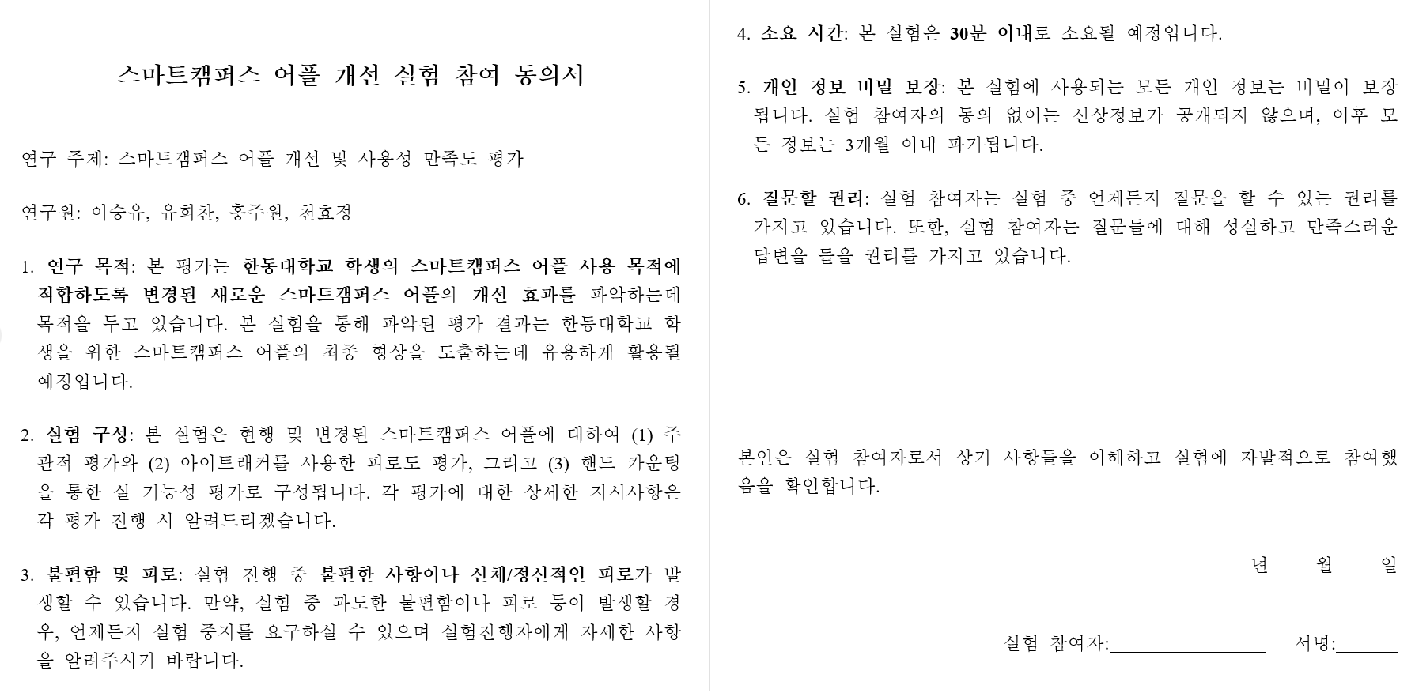

**<After experiment survey form>**

<https://forms.gle/rgPcoTzHSaPnk2S6A>

**<Interview Questions>*1-5 범위의 문항을 주고 사용자 주관적인 의견 수치화 시킬 수 있음**

* **Before interview**

1. The most used Smart Campus menus and categories

2. The most uncomfortable function from the previous version of Smart Campus

3. Satisfaction to the existing Smart Campus

* **After interview**

1. Improvements of New version Smart campus app compared with previous App

2. In commodities and Improvements from the renewal prototype

3. Expectation to further development and opinion to its improvement